**ENVIRONMENTAL MONITORING**

PHASE 4 :Submission Document

Abstract :

# This study introduces an innovative approach to environmental monitoring and urban resource management through the integration of IoT technology into parking systems. The research focuses on the development and implementation of a smart parking system that leverages IoT sensors and data analytics to monitor parking spaces in real-time. In addition to optimizing parking efficiency, the system provides insights into the environmental impact of urban congestion, air quality, and carbon emissions. By collecting and analyzing data on parking availability and its correlation with traffic and pollution levels, this study aims to reduce environmental stress, enhance urban sustainability, and improve the overall quality of life in densely populated areas. The results demonstrate the potential of IoT-based solutions to mitigate environmental challenges in urban environments while addressing practical parking issues.

Objective:

# 1. *Optimize Urban Parking:* Develop a smart parking system that efficiently manages parking spaces, reduces congestion, and improves the overall parking experience in urban areas.

# 2. *Environmental Impact Assessment:* Monitor and analyze the environmental impact of parking activities, such as traffic congestion, pollution levels, and carbon emissions.

# 3. *Real-time Data Collection:* Utilize IoT sensors and devices to collect real-time data on parking space availability, vehicle movements, and environmental parameters.

# 4. *Data Integration:* Integrate parking and environmental data into a centralized system for comprehensive analysis and decision support.

# 5. *Environmental Insights:* Provide insights into the correlation between parking patterns and environmental conditions to identify areas of concern.

# 6. *Urban Sustainability:* Contribute to urban sustainability by reducing environmental stress, improving air quality, and mitigating the negative effects of parking-related congestion.

# 7. *Resource Allocation:* Enable better allocation of urban resources and infrastructure based on data-driven insights.

# 8. *Enhanced Quality of Life:* Ultimately, enhance the quality of life for residents and visitors by creating more sustainable and livable urban environments.

TEMPERATURE AND HUMIDITY DATA:

IOT DEVICE:

Develop or use IoT devices equipped with temperature and humidity sensors.

Ensure the devices can connect to the internet, either through Wi-Fi, cellular, or other communication protocols.

Data Transmission:

Implement a communication protocol (e.g., MQTT, HTTP, CoAP) for IoT devices to send data to the platform.

Secure the communication with encryption and authentication.

Data Ingestion:

Set up a cloud-based server or gateway to receive data from IoT devices.

Store the incoming data in a database for real-time and historical analysis.

Data Processing:

Implement data processing pipelines to clean and preprocess incoming data.

Perform data validation and quality checks to ensure accuracy.

User Interface:

Develop a web-based or mobile application for users to access the data.

Design an intuitive dashboard to display real-time and historical temperature and humidity information.

Provide user authentication and authorization for data access.

Real-Time Updates:

Implement real-time data streaming using technologies like WebSockets or Server-Sent Events to display live data updates.

Consider push notifications to alert users of critical changes.

Data Visualization:

Use charts, graphs, and tables to visualize temperature and humidity data.

Offer options to customize the display, such as different time periods or sensor selection.

Alerts and Notifications:

Set up alerts based on user-defined thresholds for temperature and humidity.

Send notifications via email, SMS, or in-app alerts when thresholds are crossed.

Data Analytics:

Provide tools for users to analyze historical data, detect trends, and gain insights from the collected information.

Security:

Ensure data security and privacy by encrypting data both in transit and at rest.

Regularly update and patch the system to protect against security vulnerabilities.

Scalability:

Design the platform to handle a growing number of IoT devices and users.

Consider load balancing and auto-scaling mechanisms.

Data Storage:

Select a suitable database system for efficient storage and retrieval of historical data.

Consider data retention policies to manage long-term data storage.

API Integration:

Create APIs to allow third-party applications to access the temperature and humidity data for various use cases.

Maintenance and Support:

Establish procedures for monitoring, maintaining, and troubleshooting the platform.

Provide user support and documentation for device setup and platform usage.

Compliance:

Ensure compliance with data protection regulations (e.g., GDPR, HIPAA) and industry-specific standards.

WEB DEVELOPMENT USING HTML:

<!DOCTYPE html>

<html>

<head>

        <title> Environmental monitoring Data</title>

  <link rel="stylesheet" href="style.css">

</head>

<body>

    <h1><font color="black"><center>SHREE VENKATESHWARA HI-TECH ENGINEERING COLLEGE</font></h1>

   <center><img src="file:///C:/Users/DHILIP%20N/Downloads/logo.jpg"></center>

    <h1><font color="brown"><a href="">Environmental monitoring Data</a></center></font></h1>

  <center><img src="file:///C:/Users/DHILIP%20N/Downloads/environment%20data.png.jpeg"></center>

    <script src="script.js"></script>

    <left><p><h2>TEAM MEMBERS</h2><h3>S.NITHYA</h3></p><left>

<h3>N.DHILIP</h3>

<h3>S.NAVEENA</h3>

<h3>R.SHANMUGAPRIYAN</h3>

<h3>G.RAMAYA</h3>

<h3>K.SAKTHIVEL</h3>

    </body>

</html>

OUTPUT:

# SHREE VENKATESHWARA HI-TECH ENGINEERING COLLEGE



# Environmental monitoring Data

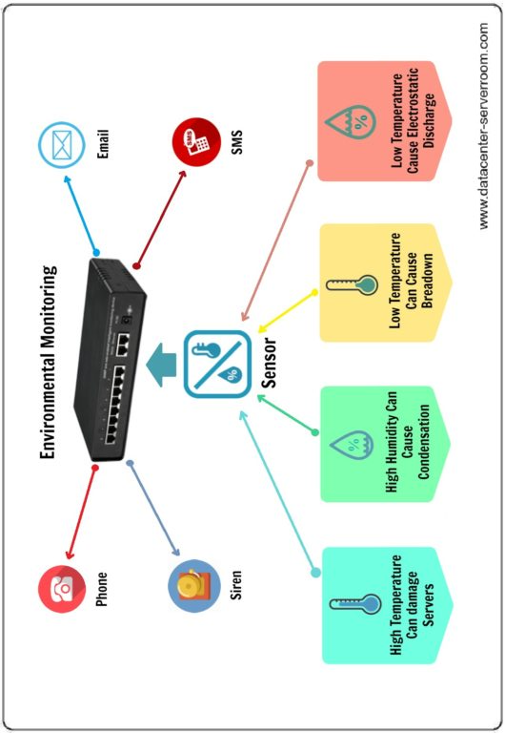

## TEAM MEMBERS

### S.NITHYA

### N.DHILIP

### S.NAVEENA

### R.SHANMUGAPRIYAN

### G.RAMAYA

### K.SAKTHIVEL